Aniebiet Daniel Akpan

Phase 2

Contents page

- Interface design

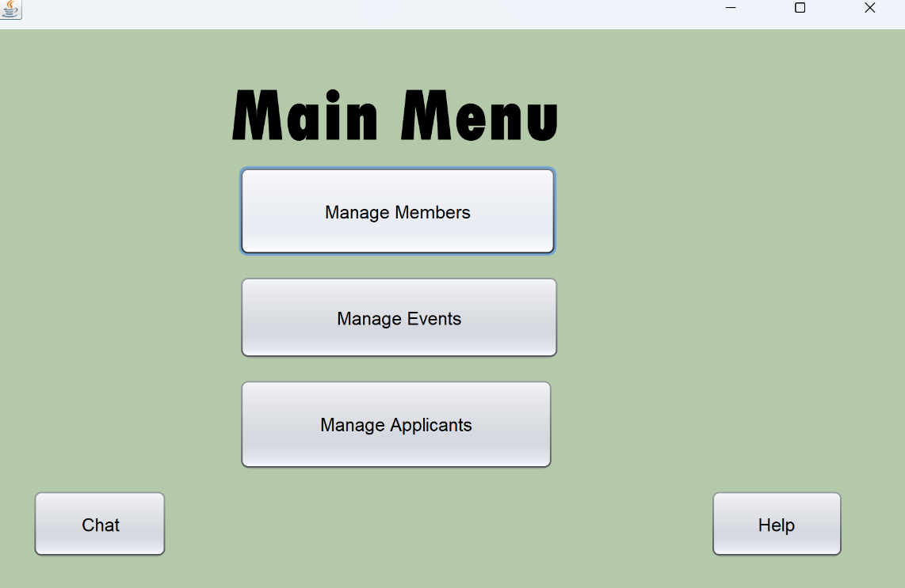
Description | This screen allows users to navigate to different screens for management
Security Group | All users
Input device | Mouse
Data | N/A
Actions | Manage Members Button: Navigates to Band Admin Screen  Manage Applicants Button: Navigates to Applicant Admin Screen  Manage Events Button: Navigates to Event Admin Screen  Help button: A popup screen shows up to inform user of what each button does.  Chat Button: opens a ChatBot for user to ask questions
Data Validation | N/A

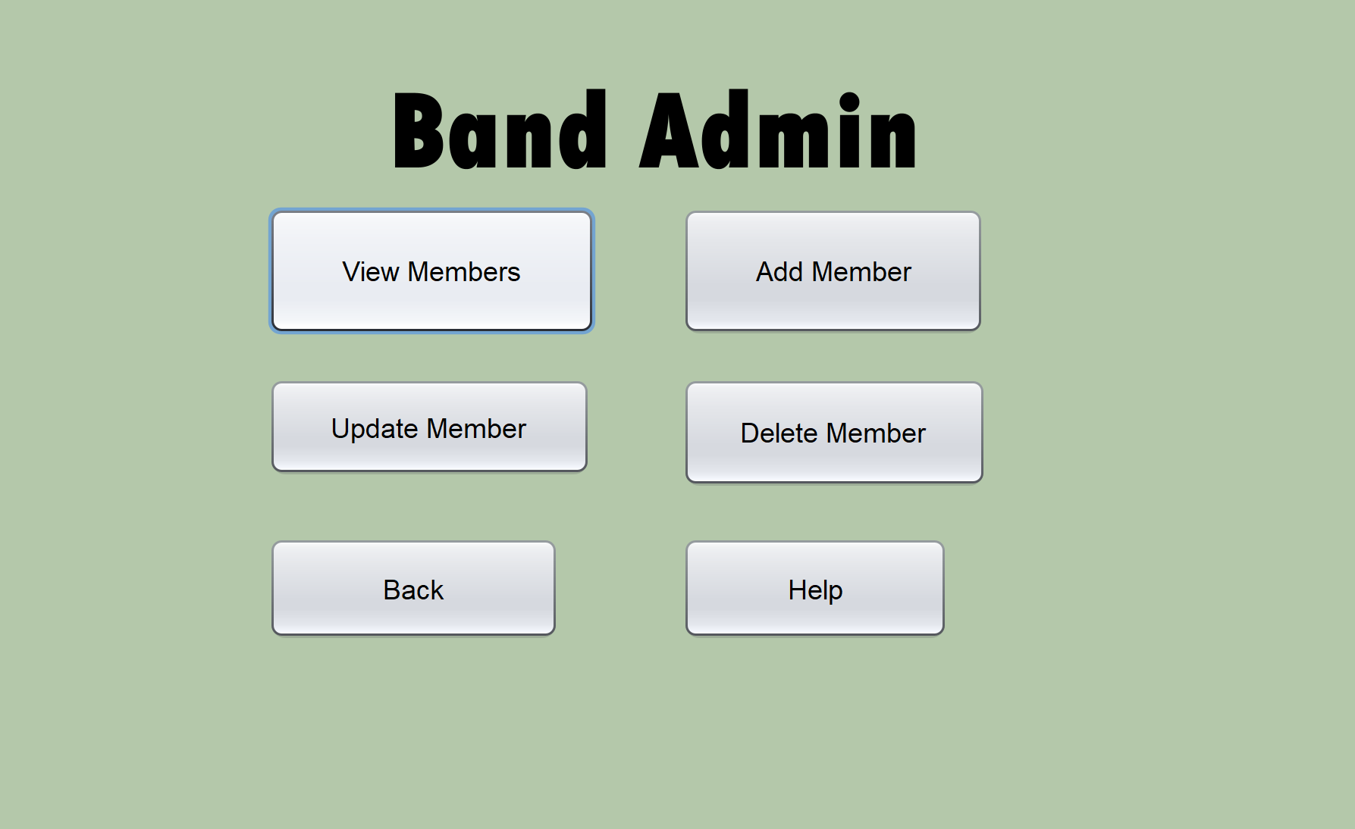

Description | Allows user to view members or navigate to the Add , Delete or Update screen.
Security Group | All users
Input device | Mouse
Data | N/A
Actions | View Members Button: Send user to view member screen  Add Member Button: Send user to Add member screen  Delete Member Button: Sends user to Delete member screen  Update Member Button: Sends user to Update screen  Back Button: Sends user back to main screen  Help: Popup screen tells user the functions of each button on screen
Data Validation | N/A

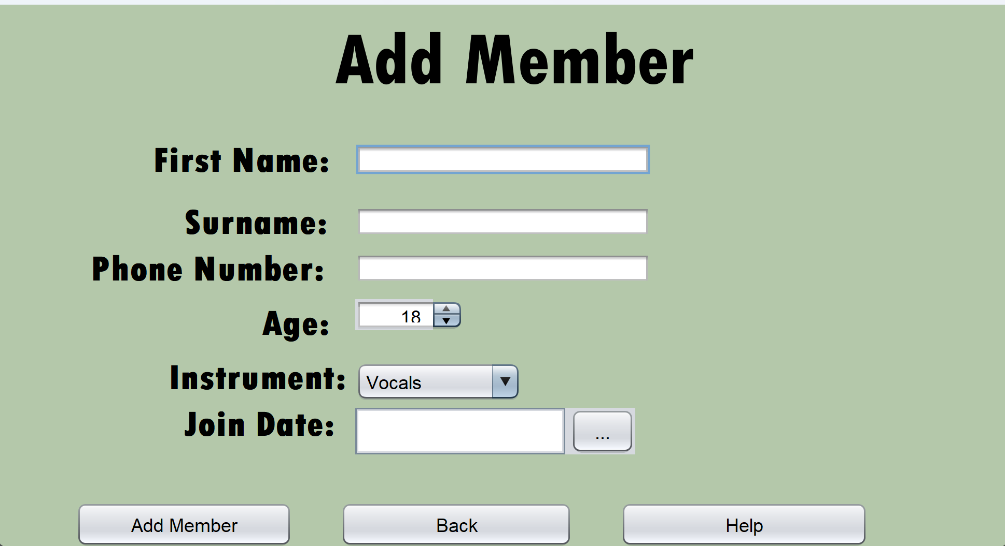

Description | This screen is used to add to the band members table
Security Group | All users
Inout device | Mouse  Keyboard
Data | Input GUI Components  - First Name: Text Field to input the member’s first name  - Surname: Text Field to input member’s surname  - Phone Number: Text Field to input member’s phone number  - Age: Spinner to select age of member  - Instrument: ComboBox to enter the instrument the member plays  - Join Date: Date Picker to select the date the member joined
Actions | Add member button: uses the entered information and creates a new member in the member table.  Help button: Displays help information from a text file.  Back button: Navigates back to the manage member screen
Data Validation | First Name  - Type Check  - Presence check  Surname  - Type Check  - Presence Check  Phone Number:  - Presence Check  - Length Check  - Type Check  Join Date:  - Logic Check  - Presence Check

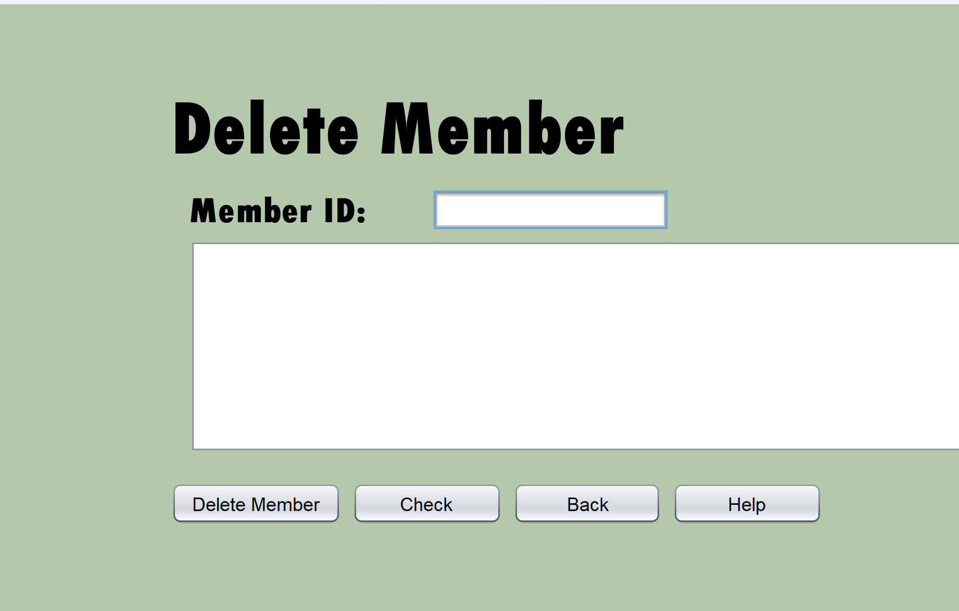

Description | This screen will allow the user to delete members from the members table and view the people before they delete them.
Security Group | All users
Input device | Mouse  Keyboard
Data | Input GUI Components  - Member ID: Text Field to enter the member ID of the member you want to delete  Output GUI components  - Scroll Pane to view the details of the member before you delete them.
Actions | Help button: Displays help information from a text file.  Back button: Navigates back to the manage member screen  Delete Member Button: Delete the member with the matching member ID  Check button: View the details of the member you are about to delete to be sure that they are the one.
Data Validation | Member ID:  - Presence Check  - Type Check  - Look up Check

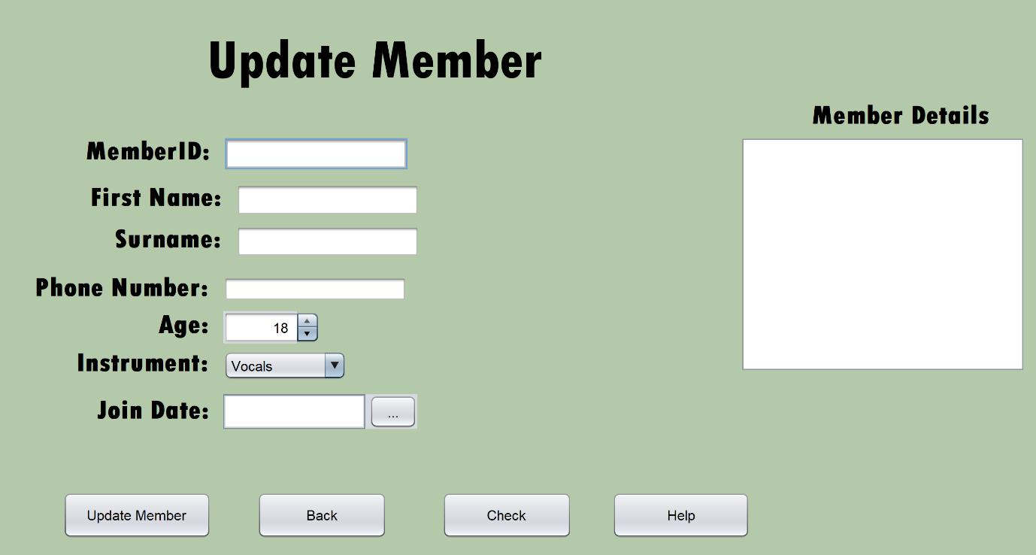

Description | This screen will allow the user to update the details of a member in the member table.
Security Group | All users
Input device | Mouse  Keyboard
Data | Input GUI Components  - Member ID: Text field to input the member ID of the member  - First Name: Text Field to input the member’s first name  - Surname: Text Field to input member’s surname  - Phone Number: Text Field to input member’s phone number  - Age: Spinner to select age of member  - Instrument: Combo Box to enter the Instrument the member plays  - Join Date: Date Picker to select the date the member joined  Output GUI components  - Scroll Pane to view the details of the member before you update them.
Actions | Help button: Displays help information from a text file.  Back button: Navigates back to the main screen  Update Member Button: updates the details of the member with the matching details  Check button: Displays the details of the member that is being updated so that user can ensure they updating the right profile
Data Validation | First Name  - Type Check  Surname  - Type Check  Phone Number:  - Length Check  - Type Check  Join Date:  - Logic Check  - Presence Check

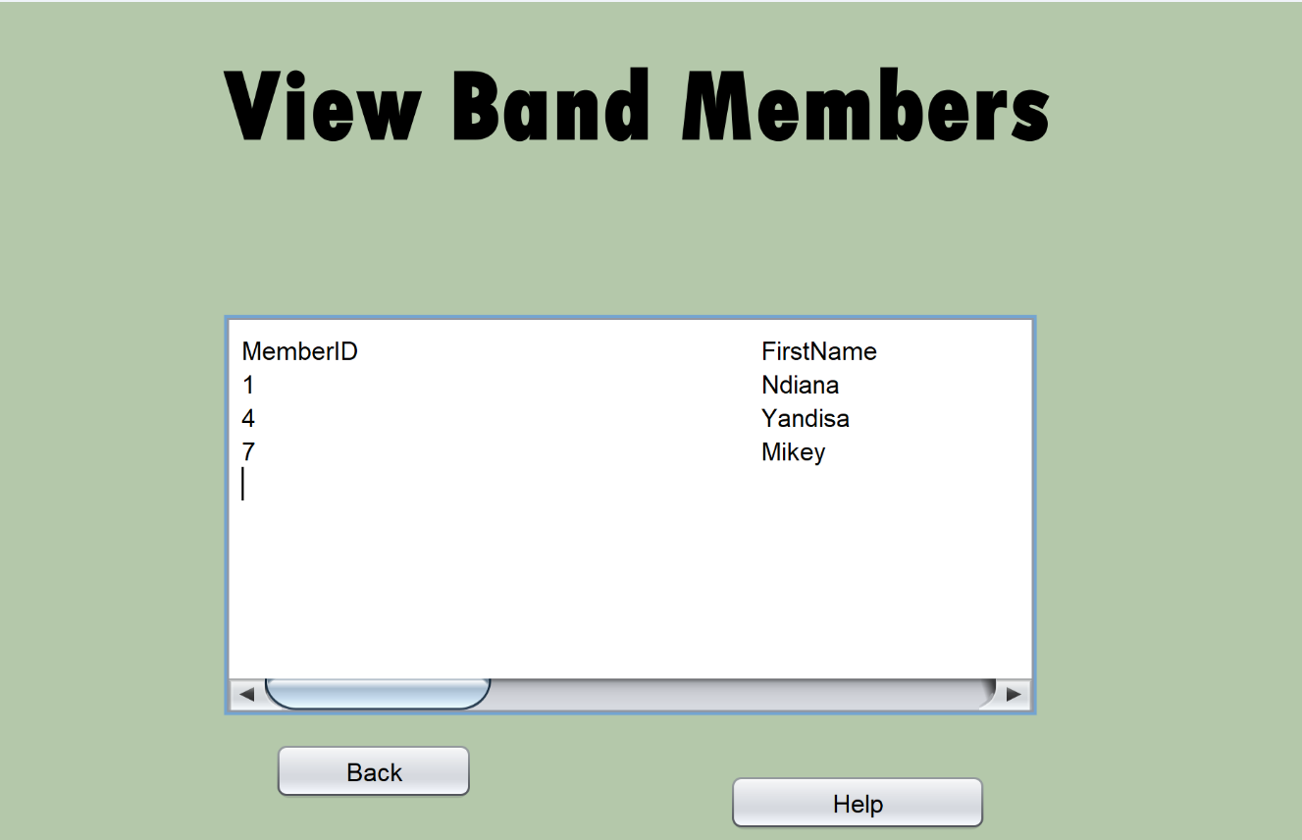
Description | This screen is used to display the content that will be in BandAdmin
Security Group | All users
Input device | Mouse
Data | Output GUI Components:  - Scroll Pane to display the Band admin content
Actions | Help button: Displays help functions from a text file in a pop up screen  Back button: Navigates back to the book admin screen
Data Validation | N/A

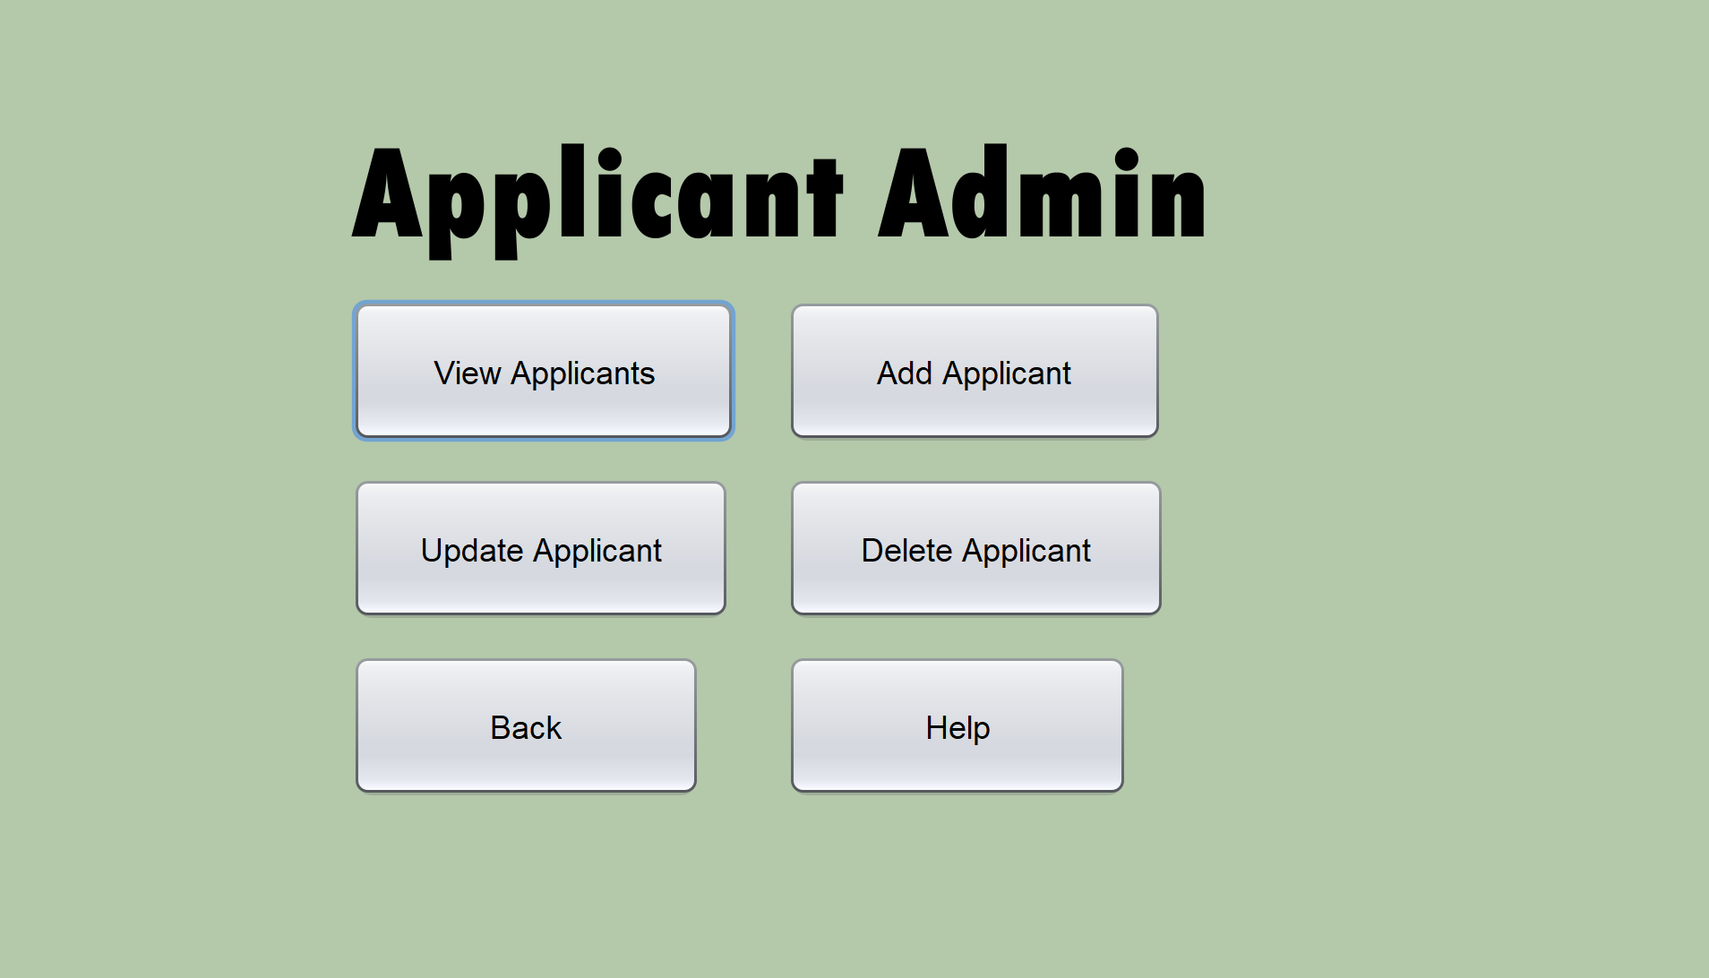

Description | Allows user to view members or navigate to the Add , Delete or Update screen.
Security Group | All users
Input device | Mouse  Keyboard
Data | N/A
Actions | View Applicants Button: Send user to view applicant screen  Add Applicant Button: Send user to Add Applicant screen  Delete Applicant Button: Sends user to Delete Applicant screen  Update Applicant Button: Sends user to Update Applicant screen  Back Button: Sends user back to main screen  Help: Popup screen tells user the functions of each button on screen
Data Validation | N/A

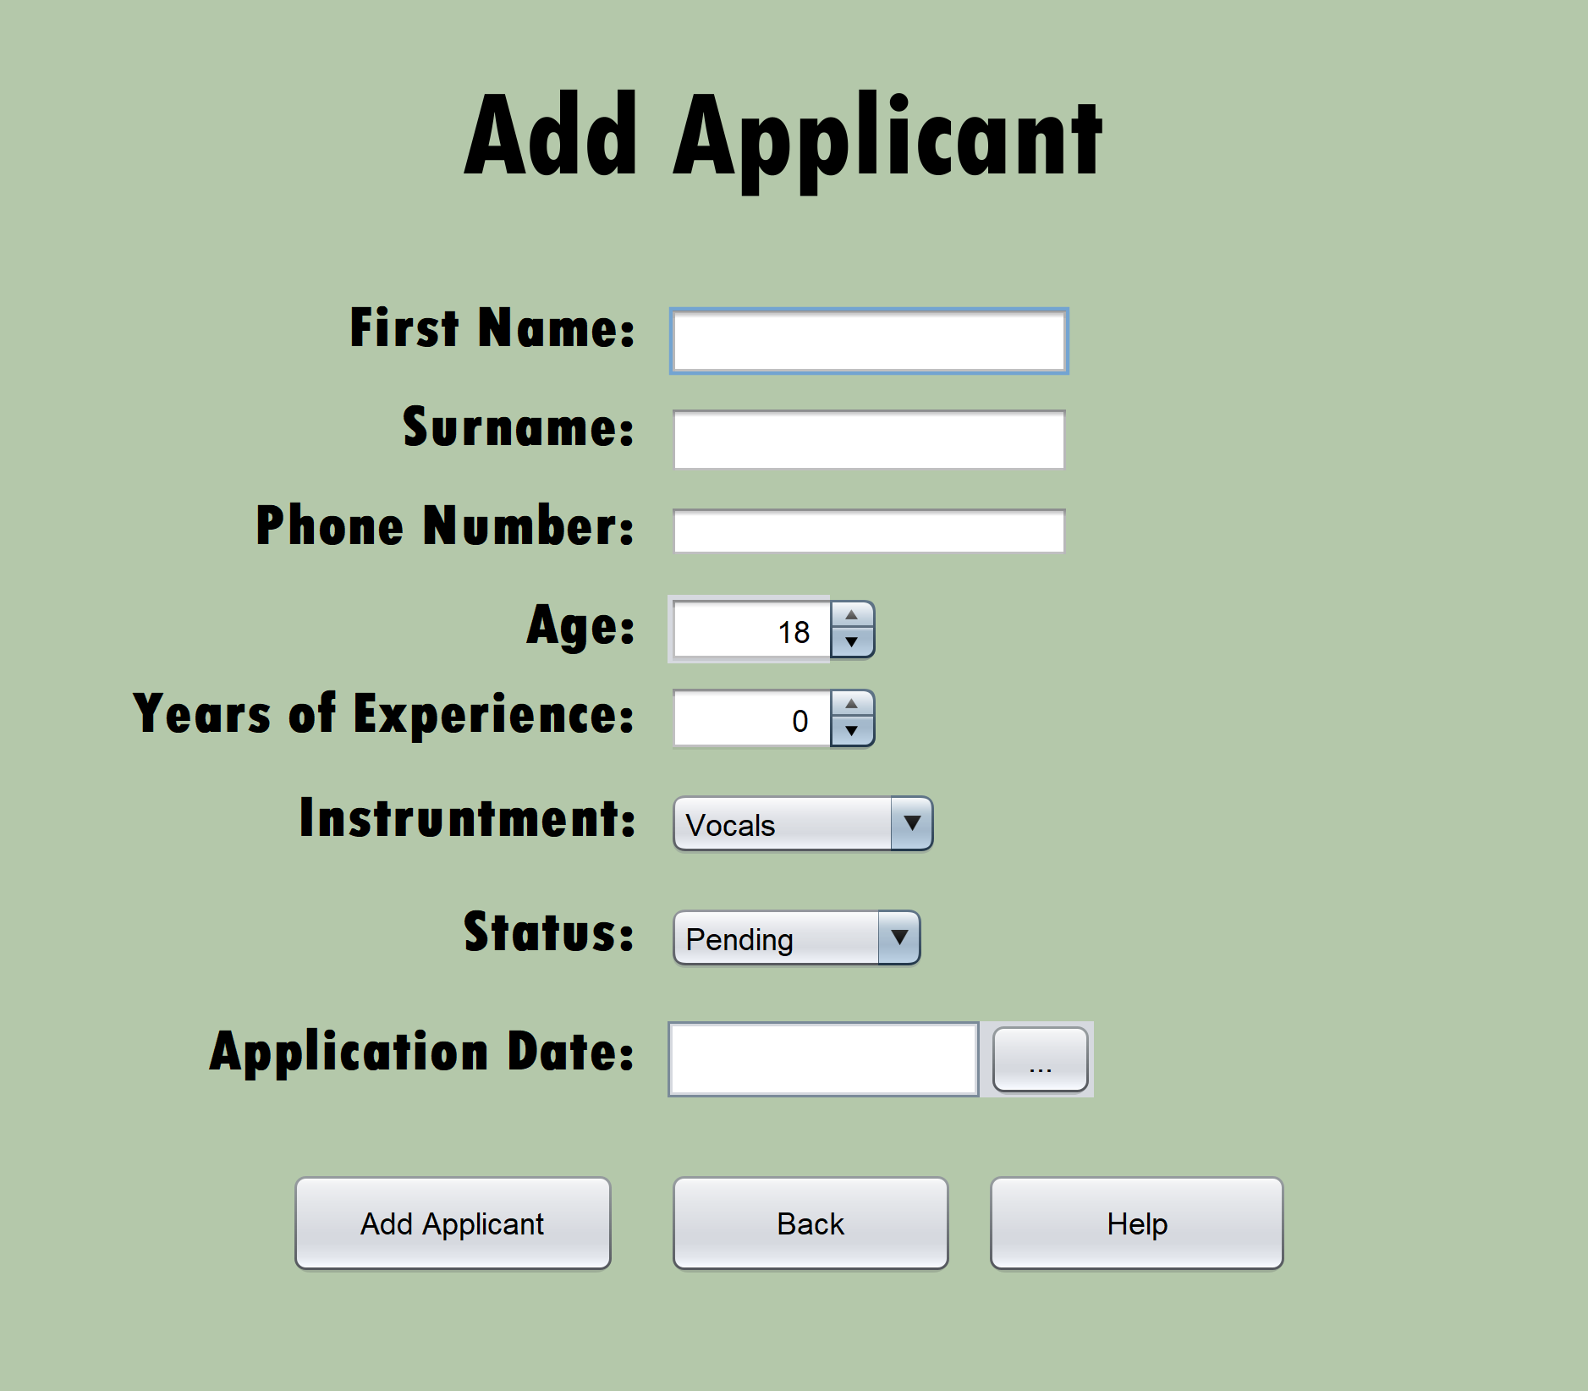

Description | This screen is used to add to the band Applicants table
Security Group | All users
Input device | Mouse  Keyboard
Data | Input GUI Components  - First Name: Text Field to input the member’s first name  - Surname: Text Field to input member’s surname  - Phone Number: Text Field to input member’s phone number  - Age: Spinner to select age of member  - Years of Experience:: Text field to enter the years of experience applicant has  - Instrument: Combo Box to enter the instrument the applicant plays  - Application Date: Date Picker to select the date the date the application came in  - Status: Text field to enter the status of their application
Actions | Add Applicant button: uses the entered information and creates a new Applicant in the Applicant table.  Help button: Displays help information from a text file.  Back button: Navigates back to the manage member screen
Data Validation | First Name  - Type Check  - Presence check  Surname  - Type Check  - Presence Check  Phone Number:  - Presence Check  - Length Check  - Type Check  Application Date:  - Logic Check  - Presence Check  Status:  - Presence Check  - Type Check

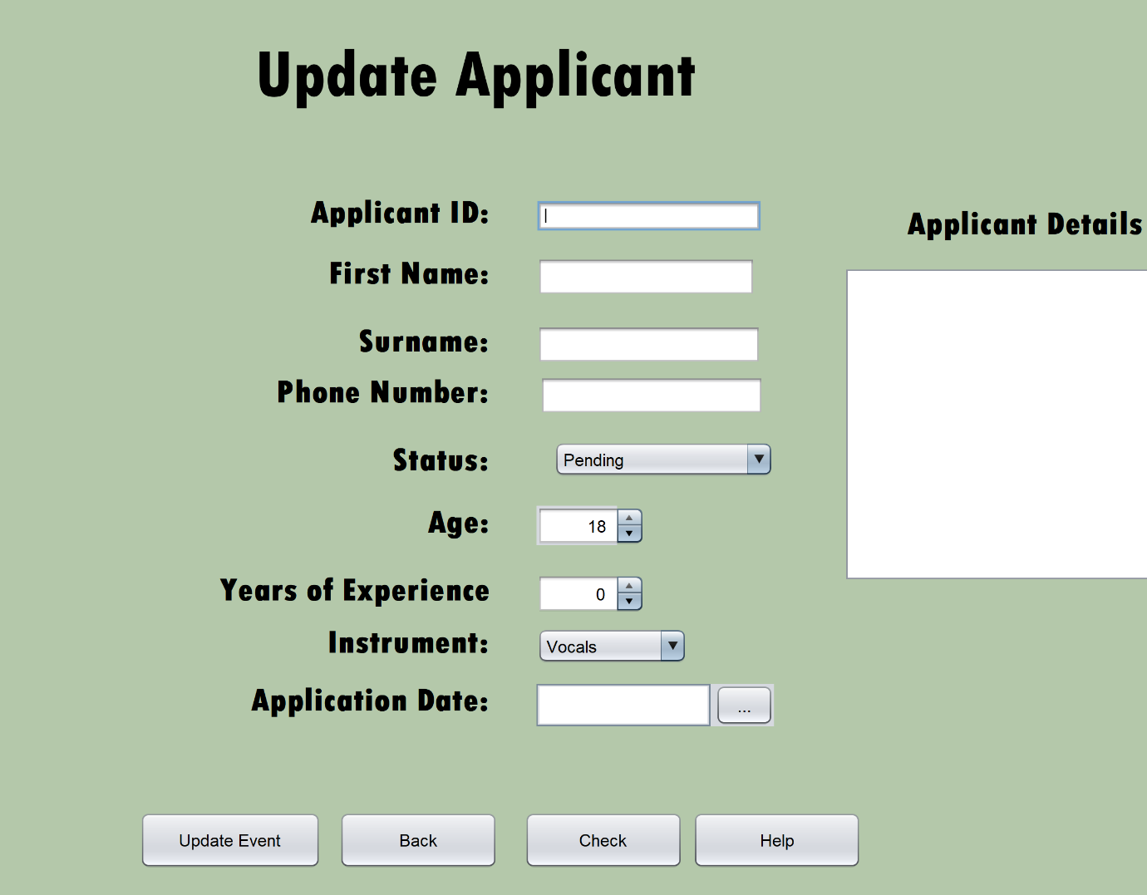

Description | This screen is used to add to the Applicants table
Security Group | All users
Input device | Mouse  Keyboard
Data | Input GUI Components  - First Name: Text Field to input the member’s first name  - Surname: Text Field to input member’s surname  - Phone Number: Text Field to input member’s phone number  - Age: Spinner to select age of member  - Years of Experience:: Text field to enter the years of experience applicant has  - Application Date: Date Picker to select the date the date the application came in  - Instrument: Combo Box to enter the instrument the applicant plays  - Status: Text field to enter the status of their application
Actions | Update Applicant button: uses the entered information and updates an Applicant in the Applicant table.  Help button: Displays help information from a text file.  Back button: Navigates back to the manage member screen  Check button: check details before updating them
Data Validation | First Name  - Type Check  Surname  - Type Check  Phone Number:  - Length Check  - Type Check  Application Date:  - Logic Check  Status:  - Presence Check  - Type Check

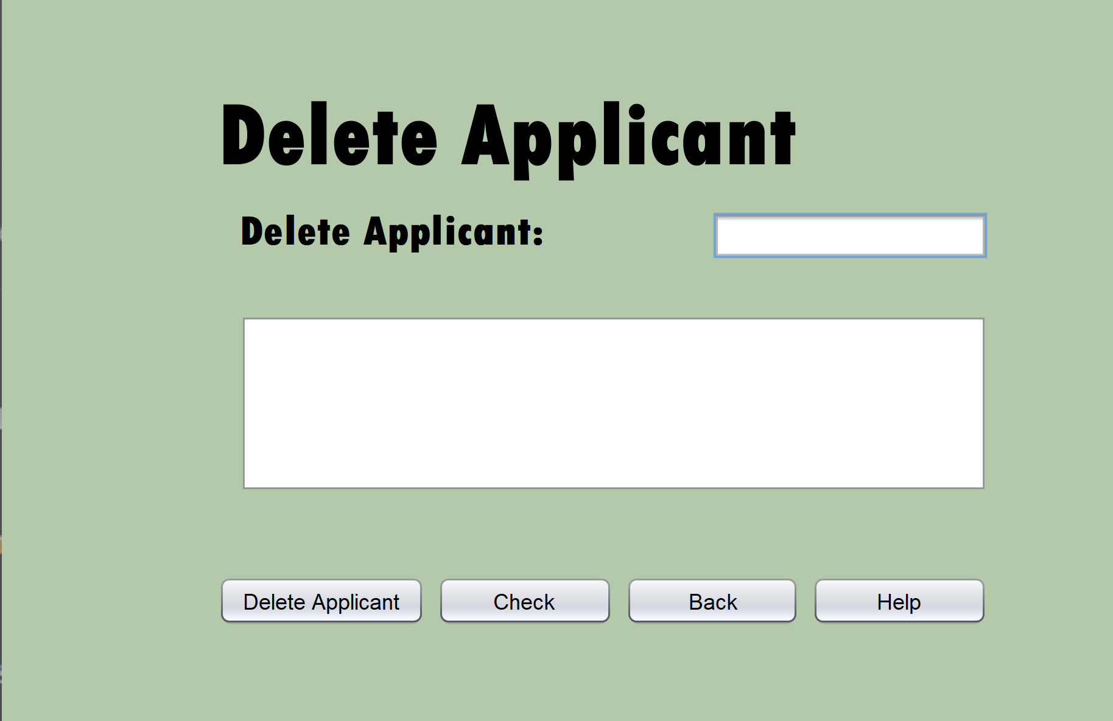

Description | This screen will allow the user to delete members from the members table and view the people before they delete them.
Security Group | All users
Input device | Mouse  Keyboard
Data | Input GUI Components  - Applicant ID: Text Field to enter the member ID of the member you want to delete  Output GUI components  - Scroll Pane to view the details of the Applicant before you delete them.
Actions | Help button: Displays help information from a text file.  Back button: Navigates back to the manage applicant screen  Delete Applicant Button: Delete the Applicant with the matching applicant ID  Check button: View the details of the applicant you are about to delete to be sure that they are the one.
Data Validation | Applicant ID:  - Presence Check  - Type Check  - Look up Check

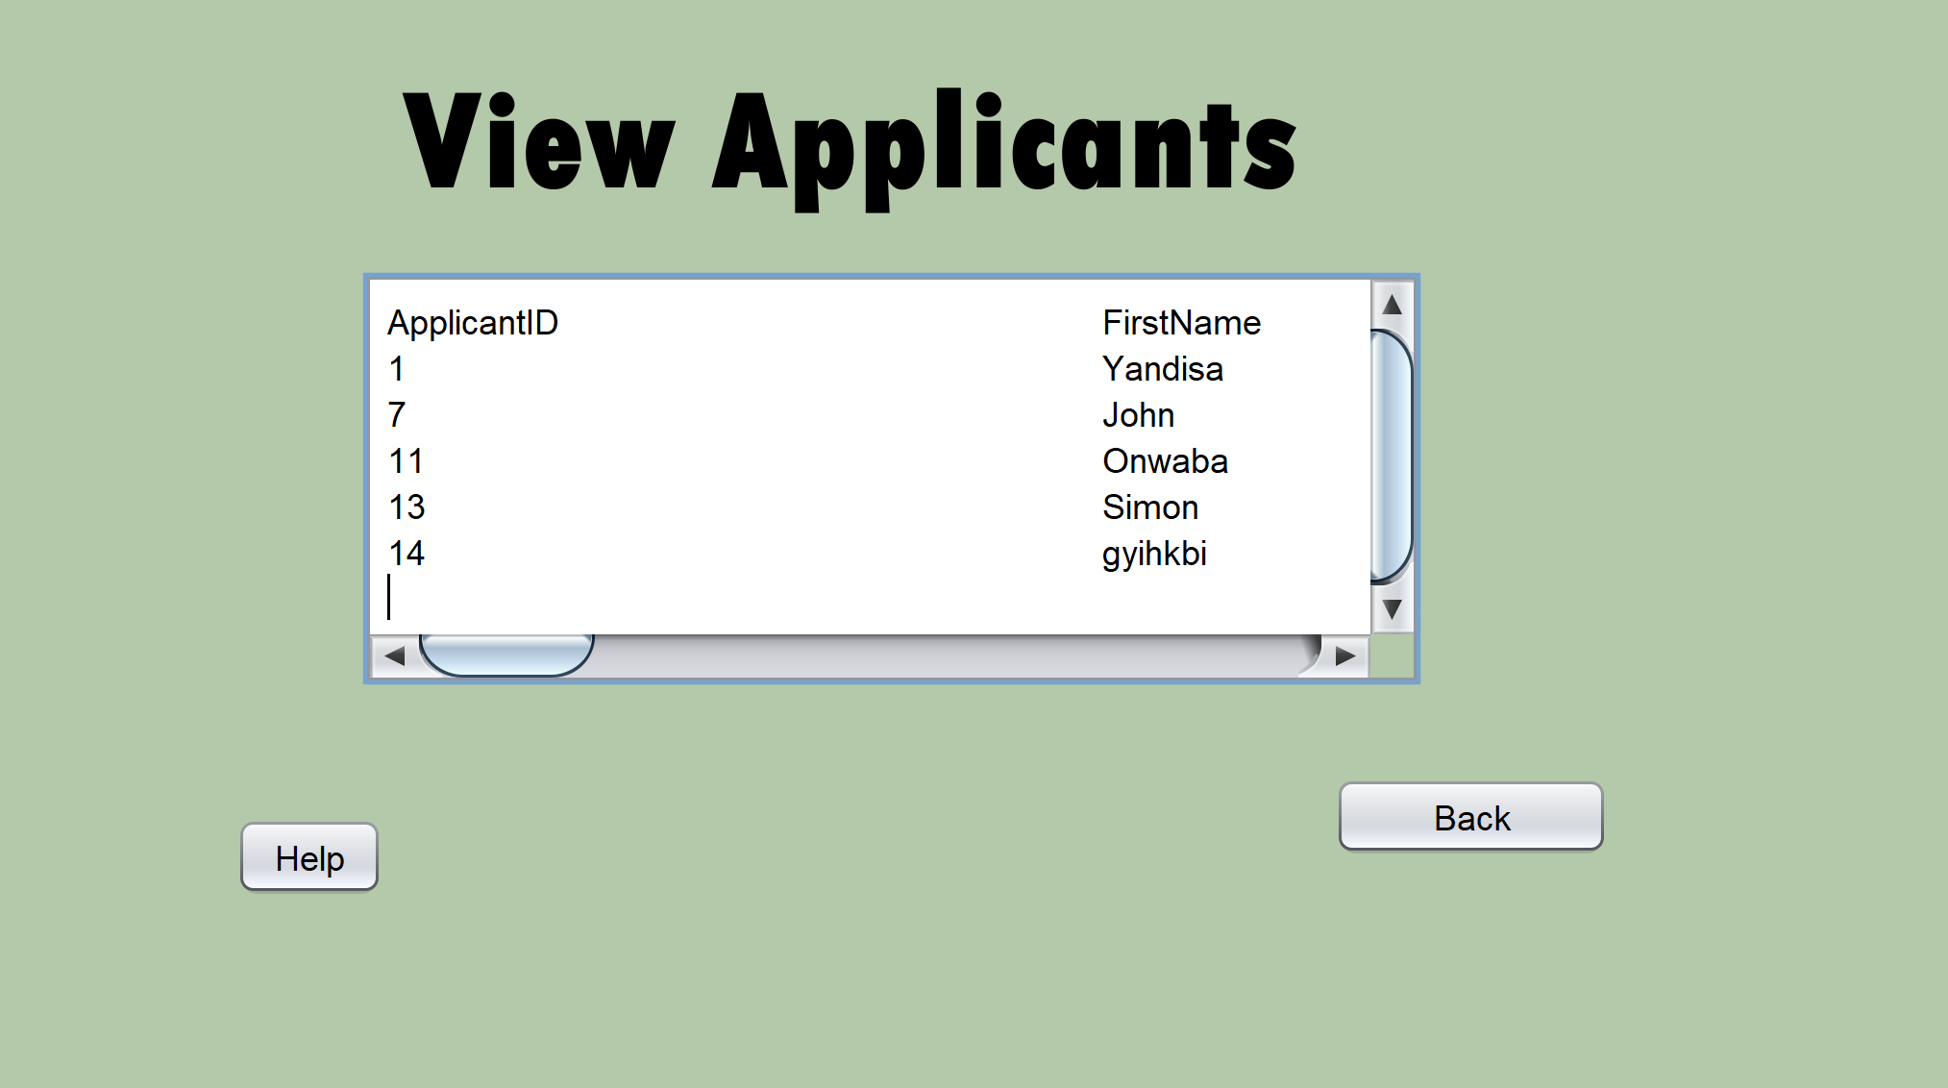

Description | This screen is used to display the content that will be in ApplicantAdmin
Security Group | All users
Input device | Mouse
Data | Output GUI Components:  - Scroll Pane to display the Band admin content
Actions | Help button: Displays help functions from a text file in a pop up screen  Back button: Navigates back to the book admin screen  View in order of experience: Displays applicants in order of most experienced to least
Data Validation | N/A

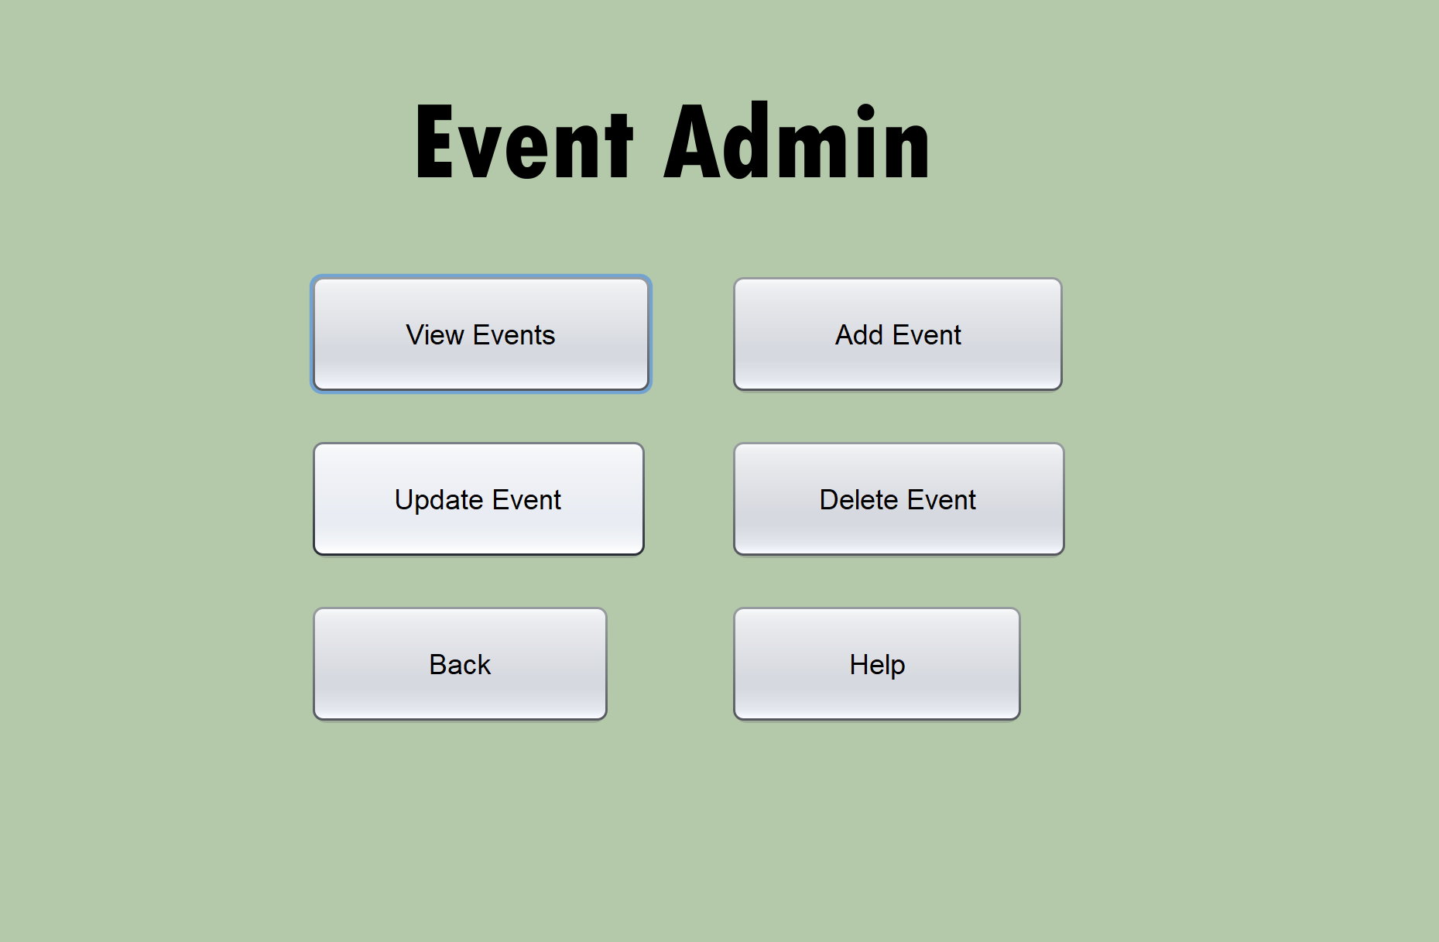
Description | Allows user to view members or navigate to the Add , Delete or Update screen.
Security Group | All users
Input device | Mouse
Data | N/A
Actions | View Events Button: Send user to view events screen  Add Event Button: Send user to Add Event screen  Delete Event Button: Sends user to Delete Event screen  Update Event Button: Sends user to Update Event screen  Back Button: Sends user back to main screen  Help: Popup screen tells user the functions of each button on screen
Data Validation | N/A

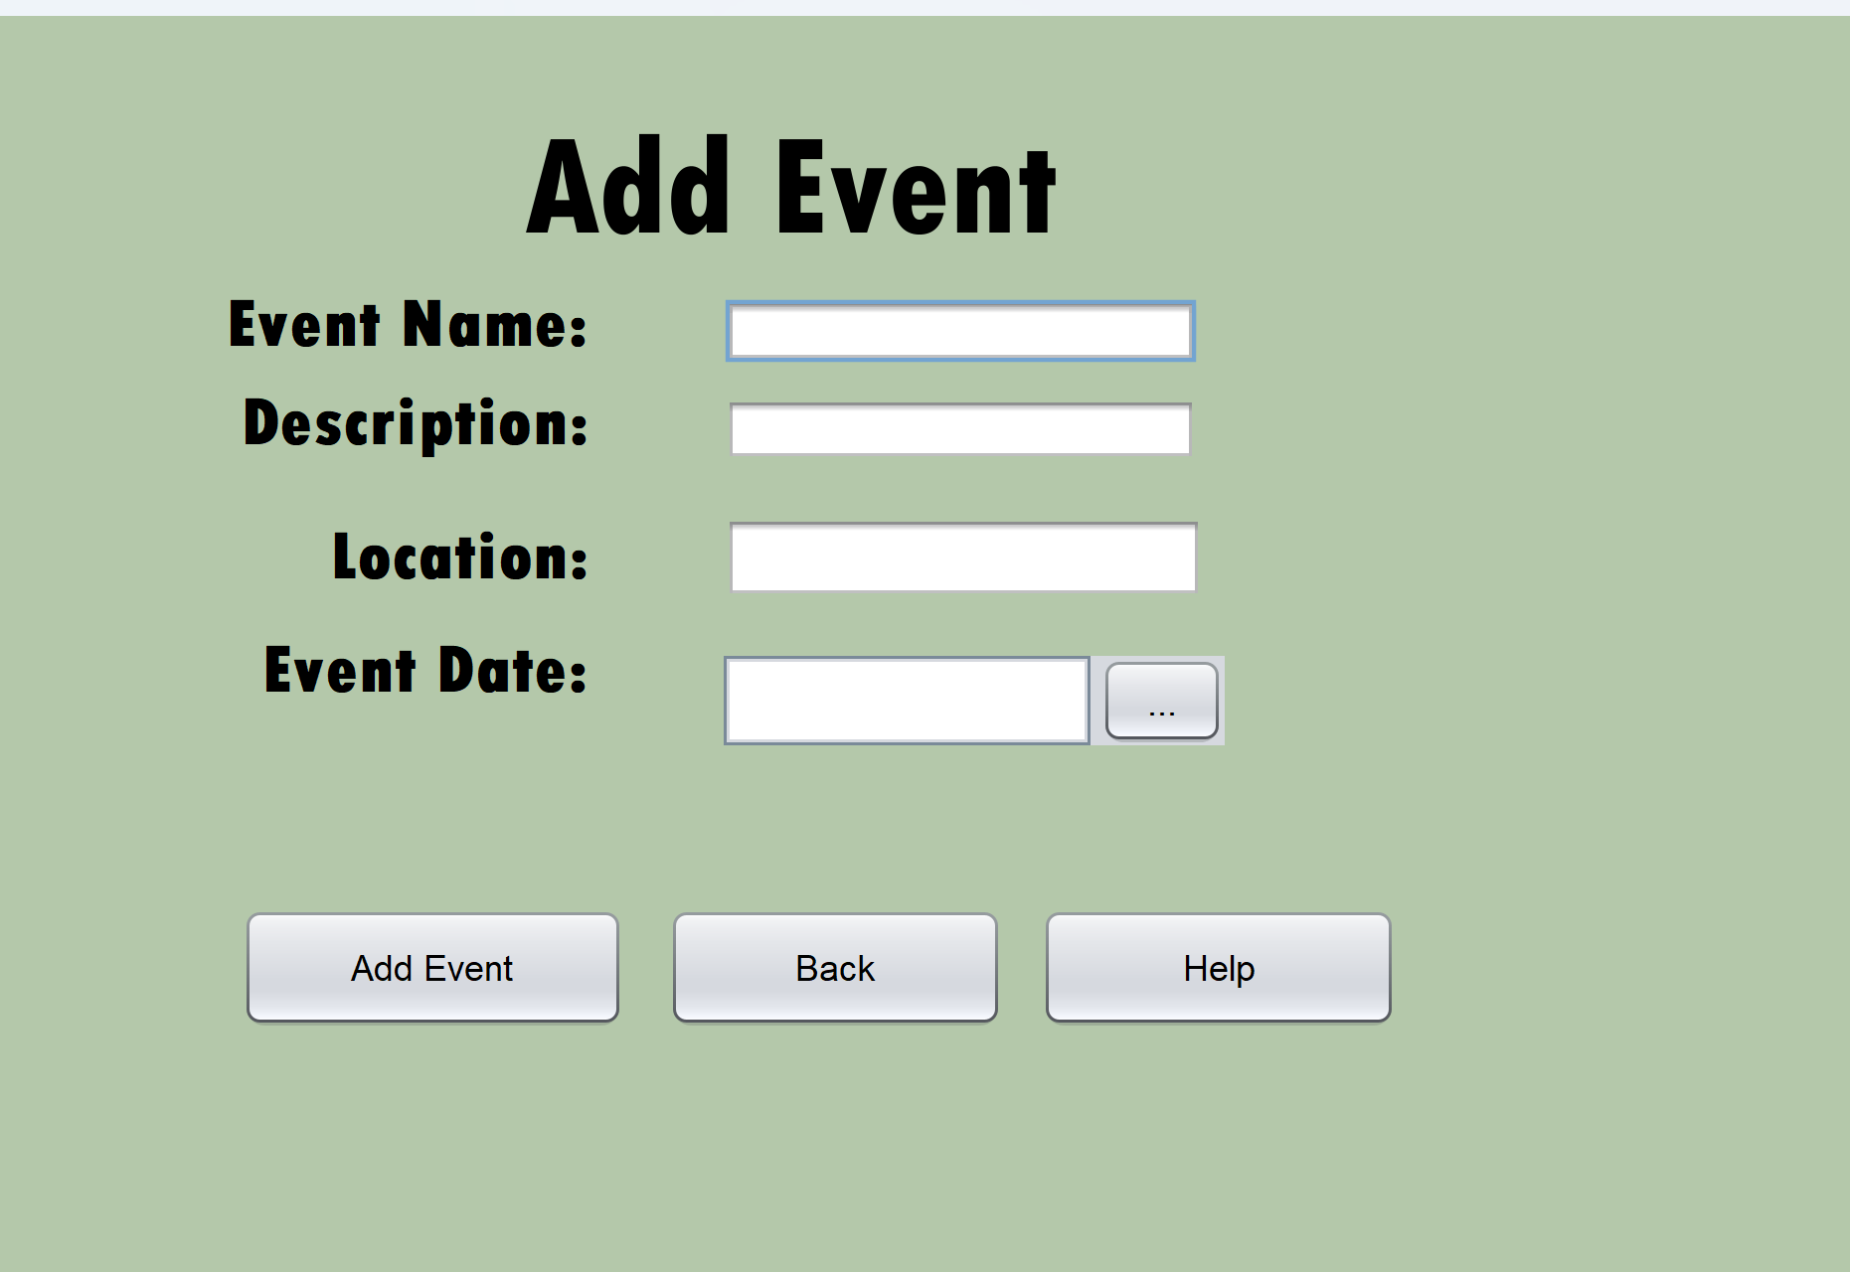
Description | This screen is used to add to the band Applicants table
Security Group | All users
Input device | Mouse  Keyboard
Data | Input GUI Components  - Event Name: Text Field to input the member’s first name  - Location: Text field to enter the location of the event  - Event Date: Date Picker to select the date of the event  - Description: Text field to enter the performance description
Actions | Add Applicant button: uses the entered information and creates a new Applicant in the Applicant table.  Help button: Displays help information from a text file.  Back button: Navigates back to the manage member screen
Data Validation | Event Name  - Type Check  - Presence check  Location  - Type Check  - Presence Check  Description  - Presence Check  - Type Check  Event Date:  - Logic Check  - Presence Check

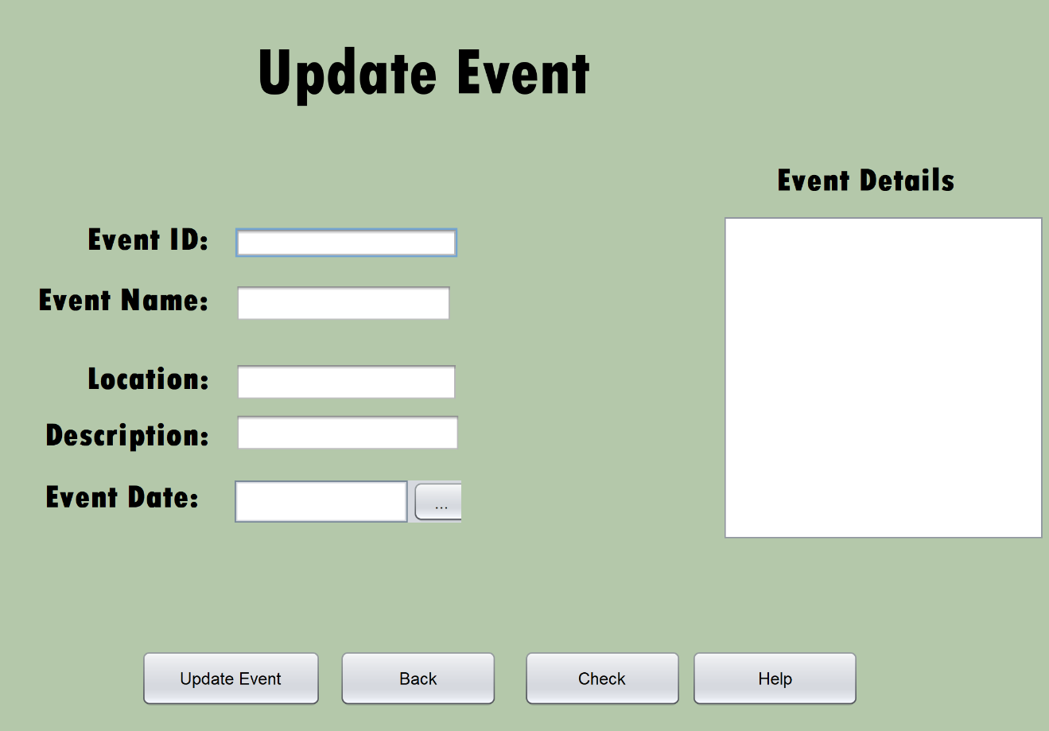
 | Description | This screen is used to update the band Applicants table
 | Security Group | All users
Input device |  | Mouse  Keyboard
 | Data | Input GUI Components  - Event Name: Text Field to input the member’s first name  - Location: Text field to enter the location of the event  - Event Date: Date Picker to select the date of the event  - Event ID: Text field to enter the ID of the event  - Description: Text field to enter the description of the performance  Output GUI Components  - Event Details: Scroll Pane to view the details of the person that is going to be updated
 | Actions | Update Event button: uses the entered information and creates a new Event in the Event table.  Help button: Displays help information from a text file.  Back button: Navigates back to the manage member screen  Check: Displays the details of the event that you are about to update so the user can see if they are updating the right event or fields
 | Data Validation | Event Name  - Type Check  Location  - Type Check  Description  - Presence Check  Event ID:  - Type check  - Presence Check  Event Date:  - Logic Check

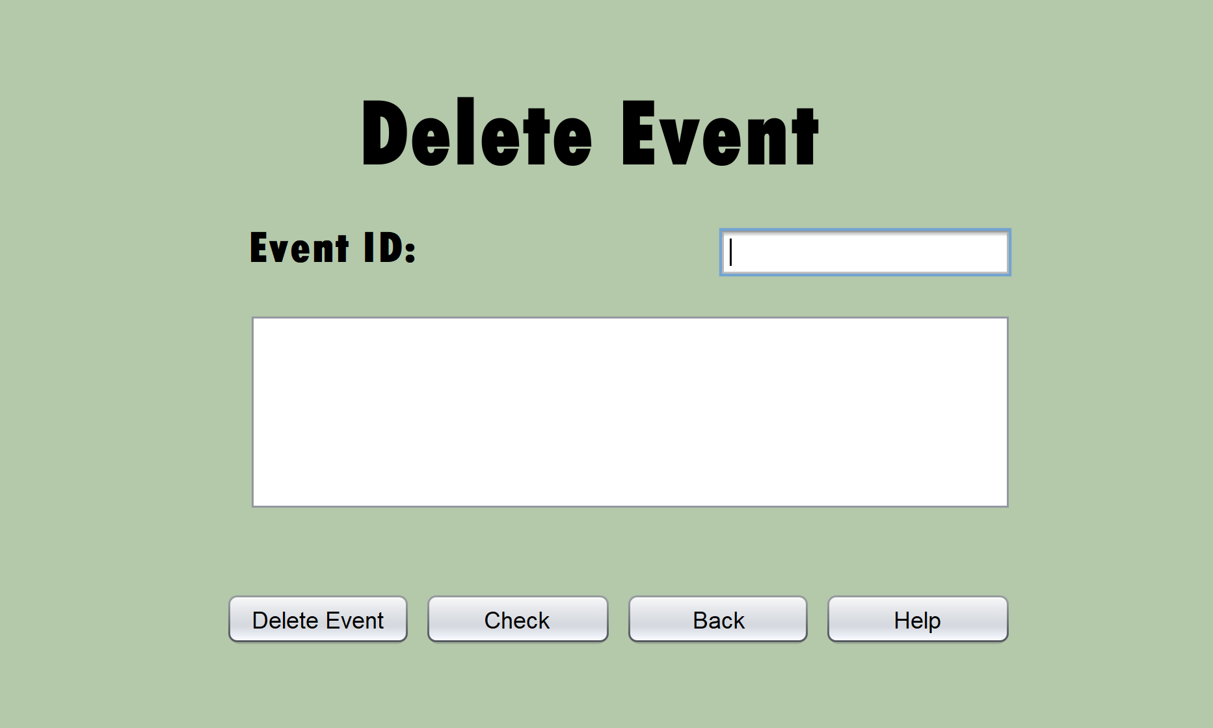

 | Description | This screen will allow the user to delete events from the Events table and view the events before they delete them.
 | Security Group | All users
Input device |  | Mouse  Keyboard
 | Data | Input GUI Components  - Event ID: Text Field to enter the member ID of the member you want to delete  Output GUI components  - Scroll Pane to view the details of the Applicant before you delete them.
 | Actions | Help button: Displays help information from a text file.  Back button: Navigates back to the manage applicant screen  Delete Event Button: Delete the Event with the matching Event ID  Check button: View the details of the Event you are about to delete to be sure that it is the right one.
 | Data Validation | Delete ID:  - Presence Check  - Type Check  - Look up Check

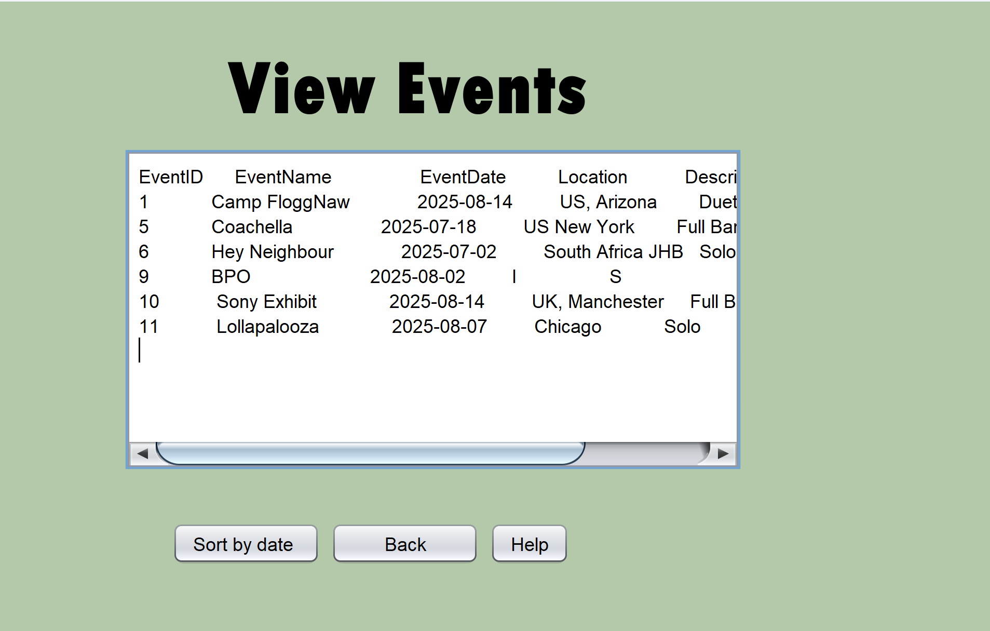

 | Description |  | This screen is used to display the content that will be in EventAdmin
 | Security Group |  | All users
Input device |  | Mouse  Keyboard
 | Data |  | Output GUI Components:  - Scroll Pane to display the event admin content
 | Actions |  | Help button: Displays help functions from a text file in a pop up screen  Back button: Navigates back to the event admin screen  Sort by date button: Sorts the event dates in descending order from closest to latest event
 | Data Validation |  | N/A

2.Program flow
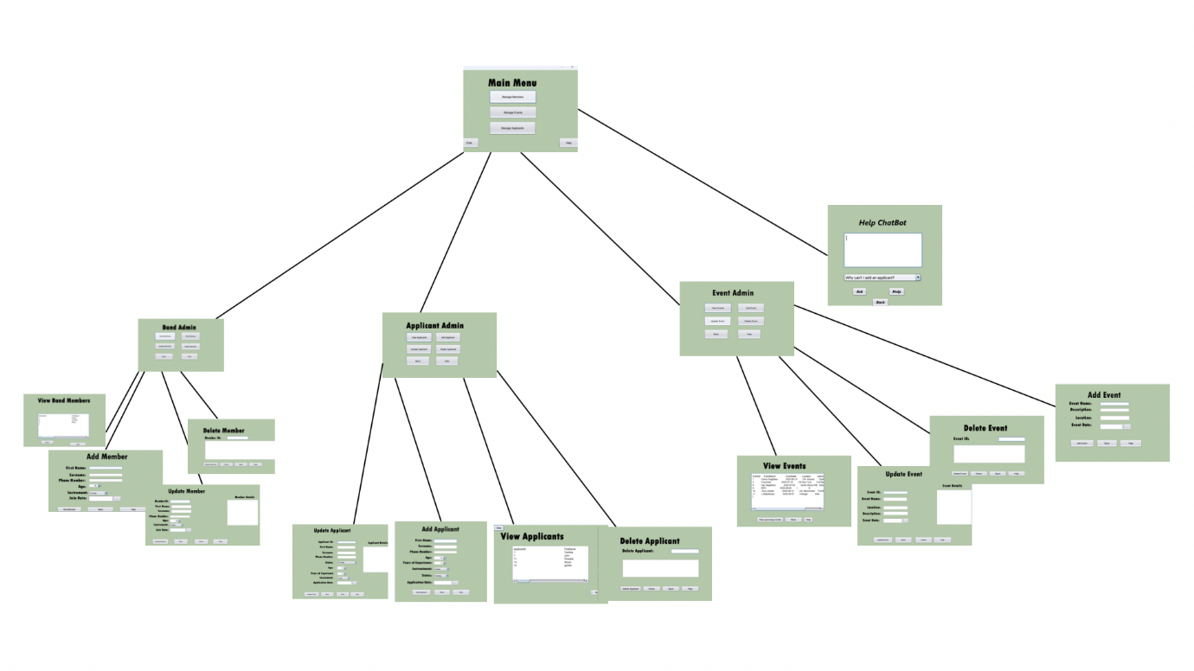

3. CLASS DESIGN AND OOP PRINCIPLES

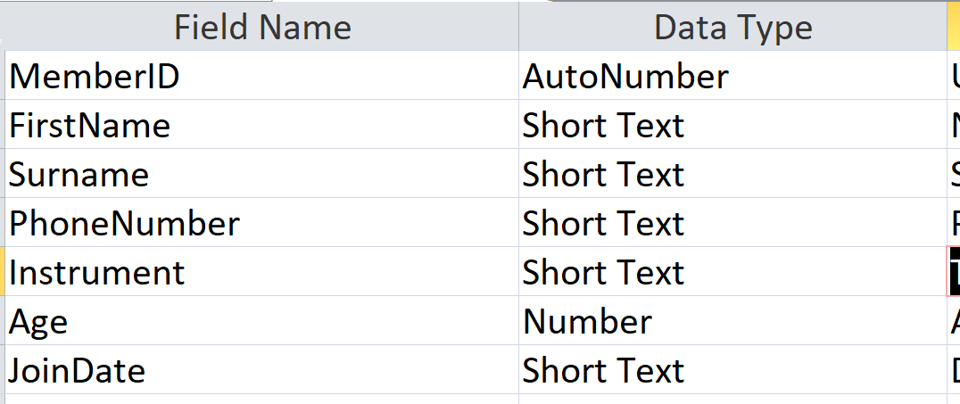

BandObj
Fields | Description
- ID: integer | Holds unique ID number for users
- FirstName: String | Holds first name for member
- Surname: String | Holds surname for member
-PhoneNumber: integer | Holds phone number of band member
- Instrument: String | Holds the instrument of the band member
-Age: integer | Holds the age of the member
-JoinDate: Date | Holds the date the member joined
Methods
+ Constructor { MemberID:integer, FirstName: String, Surname: String, PhoneNumber: integer, Instrument: String  Age: integer,  JoinDate: Date} | Instantiates member object and assigns values to the fields of the object.
+ getID: String | Returns the username of the user
+ getInstrument: String | Returns the password of the user
+ getAge:
+ toString: String | Returns a String off all the values

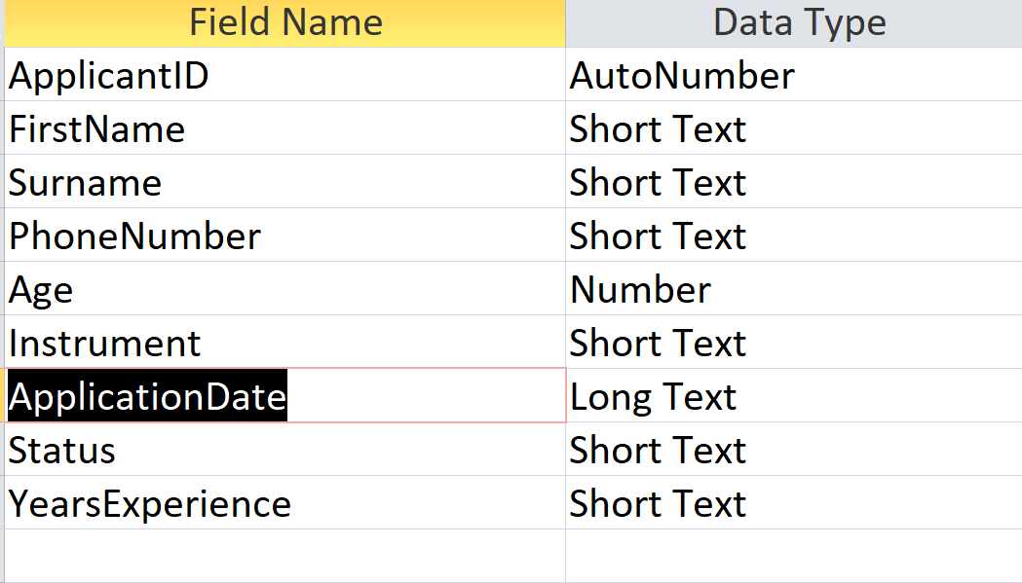

ApplicantObj
Fields | Description
-ID:integer | Holds the unique ID number for each Applicant
- applicationDate: Date | Holds the date the application was made
- Status:String | Holds the status of the application
- yearsExp:integer | Holds the number of years of experience applicant has
Methods
+ Constructor{ int aID, String fN, String sN, int pN, int a, String instrument, LocalDate aD, String s, int yE } | Instantiates applicant object and assigns values to the fields of the object.
+ getYearsExp(): integer | Returns the years of experience
+ toString: String | Returns a String off all the values

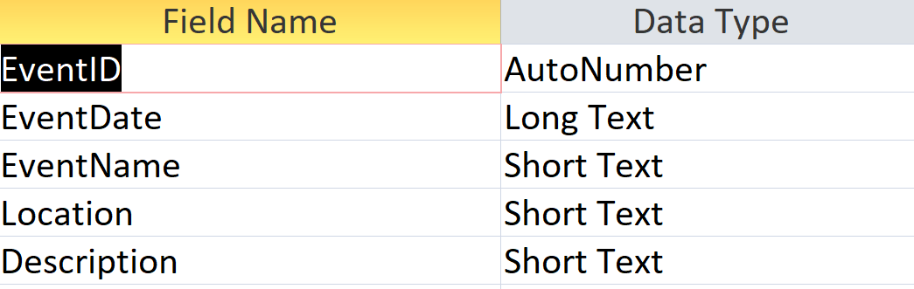
EventObj
Fields | Description
- eventID:integer | Holds the unique ID number for each Event
- eventDate:Date | Holds the date for each event
- eventName: String | Holds each event name
- location:String | Holds the location of event
- description:String | Holds the type of performance
Methods
+ Constructor{ String eventID, LocalDate eventDate, String eventName, String location, String description } | Instantiates member object and assigns values to the fields of the object.
+getEventID():integer | Returns the ID of the applicant
+ getEventDate(): Date | Returns the years of experience
+ getDescription():String
+ getEventName():String
+ toString: String | Returns a String off all the values

MemberManager
Fields | Description
-bArr[ []: BandObj | Holds array of objects of all members details
-counter: integer | Holds number of objects
-valid: Validation | Initiates an object for validation
Methods
+ Constructor () | Reads data from the tblMembers table and creates an object for each member
+ deleteMember(mid:integer) | Deletes a member in the database based on the memberID given
+ updateMember(MemberID:integer, FirstName: String, Surname: String, PhoneNumber: integer, Instrument: String  Age: integer,  JoinDate: Date) | Updates a member in the database with the relevant details
+ addUser(FirstName: String, Surname: String, PhoneNumber: integer, Instrument: String  Age: integer,  JoinDate: Date) | Inserts a member into the database with the relevant details
+ viewMembers():string | Displays the members
+ sortMembers(age: integer) | Orders members from old to young

ApplicantManager
Fields | Description
- aArr[]: ApplicantObj | Holds array of objects of all the appicant details
- counter: integer | Holds number of objects
Methods
+ Constructor () | Reads data from the tblApplicants table and creates an object for each applicant
+ updApplicant(int aID, String fN, String sN, int pN, int a, String in, LocalDate aD, String s, int yE) | Updates details of applicant that has the matching ID
+ addApplicant(String fN, String sN, int pN, int a, String in, LocalDate aD, String s, int yE) | uses the given data to create a new object in the array of objects and the database
+ deleteApplicant(aid: String) | Removes applicant with the matching ID from the applicant table
+ viewApplicants() | Displays applicants
+ sortApplicants() | Sort in descending order of experience

EventManager
Fields | Description
-eArr[]: EventObj | Holds array of objects of all the event details
- counter: integer | Holds number of objects
Methods
+ Constructor () | Reads data from the tblEvents table and creates an object for each event
+ addEvent(LocalDate eventDate, String eventName, String location, String description) | uses the given data to create a new object in the array of objects and the database
+updEvent(String eventID, LocalDate eventDate, String eventName, String location, String description) | Updates details of event that has the matching ID
+deleteEvent(eID: integer) | Deletes event with the matching ID
+viewEvents() | Displays events in event table
+upcomingEvents() | Orders events in order of how close they are to today’s date

Connect
Fields | Description
- conn: Connection | Connects to the Database11 database in Microsoft Access
Methods
+ Constructor | Establishes a connection by instantiating a connect object
+ query(String sql): Resultset | Executes regular statements in Database11 database
+ insert(String sql): Integer | Inserts into Database11  database
+ update(String sql): Integer | Updates details in the Database11 database

SimpleHelp
Fields | Description
Methods
+ show() | Reads data from the help text file and displays it as a JOptionPane message

 | NLPProcessor
 | Fields | Description
 | Methods
 | - tokenizer | Internal tokenizer instance (from OpenNLP)
 | + NLPProcessor() | Initializes tokenizer using a model file.
 | + tokenize(text: String): String[] | tokenizes the given text using the initialized tokenizer. Returns empty array if not initialized.
BackGroundMusic
Fields |  | Description
Methods
- backgroundClip : Clip |  | Static audio clip used for background music playback
+ play(filepath: String) : void |  | Plays background music from the given file path in a continuous loop. Initializes the clip if not already running.
+ stop() |  | Stops the background music if it is currently running.

4. SECONDARY STORAGE DESIGN
My program has an Access database called Database 11. It will store information about the members in tbl Members, for events in tblEvents and for Applicants in tblApplicants .

MemberAdmin: this will be used to store all of the details of the users who played the game

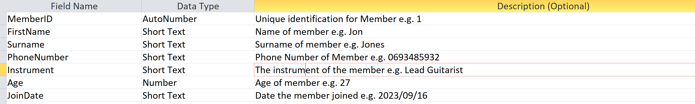
- FIELD SIZES: MemberID(Long Integer), First Name(30), Surname(30), Phone Number(10), Instrument(20), Age(Long integer)
- PRIMARY KEY: MemberID
- FOREIGN KEY: None

- SAMPLE:
- 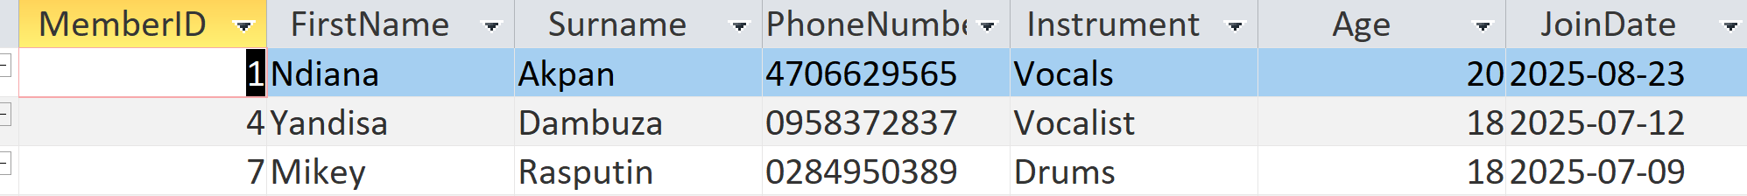

ApplicantAdmin: this will be used to store the information for each applicant

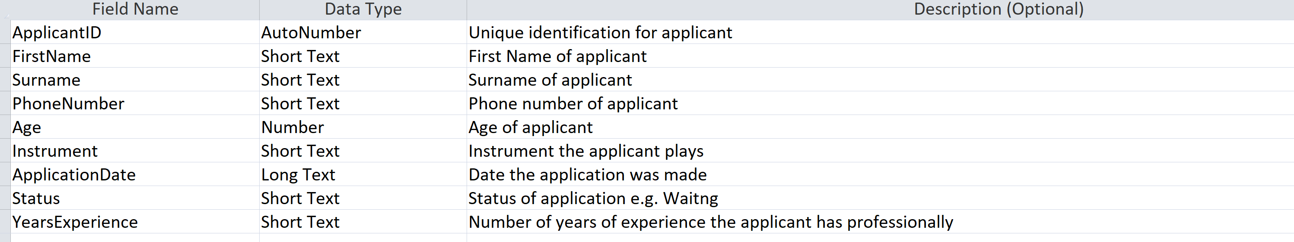
- FIELD SIZES: ApplicantID(Long Integer), First Name(30), Surname(30), Phone Number(10), Age(Long Integer), Instrument(20), Status(20), YearsExperience(4)
- PRIMARY KEY: ApplicantID
- SAMPLE:
- 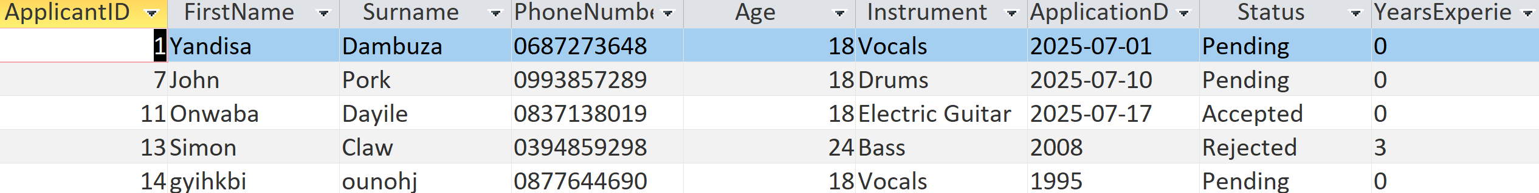

EventAdmin: this will be used to store the information for each event

- FIELD SIZES: EventID(Long Integer), EventName(30), Location(40), Description(30)
- PRIMARY KEY: EventID
- SAMPLE:
- 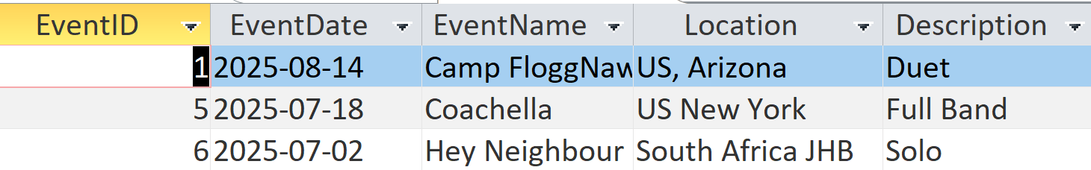

- Relationships in the database

The help information will be shared in a text file called PATHelp.txt, there will only be one help text file used throughout the program. The questions a long with the answers will also be stored on a text file called PATQuestions.

5. EXPLANATION OF SECONDARY STORAGE DESIGN

I stored the Member, Event and applicant details in a database as opposed to a text file because it is much easier to edit and add data in this storage medium. It will also allow me to query data more efficiently along with forming relationships between the three tables so that the data can be linked easily. The database keeps all the data consistent and is more secure than a text file. This storage medium eliminates possible updating errors and eliminates potential data redundancy. Any changes made to the database occur in real time which ensures that data is always up to date.

The help information has been stored in a text file because there is no need to update or query the help text file and it also avoids reduces storage space for simple data. It is easy to access and there is no redundancy. It is simple and ideal for this data which is small.

6. EXPLANATION OF PRIMARY DATA STRUCTURE RELATED TO SECONDARY STORAGE

Members

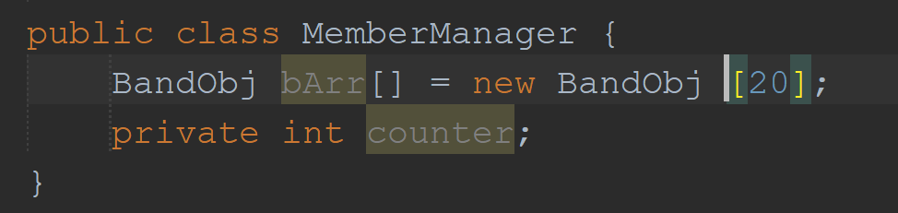

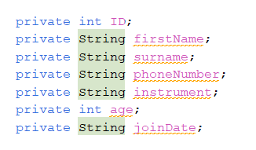

Data is loaded into the MemberManager class from MemberAdmin through the connect class in the format of the Member object class. bArr[].Memberis the primary data structure which will represent MemberAdmin which is the secondary data structure. The fields in Member match the variables in the MemberAdmin object class.

Fields | bArr[0] | bArr[1]
bArr[i].memberID | 1 | 2
bArr[i].firstName | Ndiana | Yandisa
bArr[i].surname | Akpan | Dambuza
bArr[i].phoneNumber | 4706629565 | 0958372837
bArr[i].instrument | Vocals | Vocalist
bArr[i].age | 20 | 18
bArr[i].joinDate | 2025-08-23 | 2025-07-12

Applicants
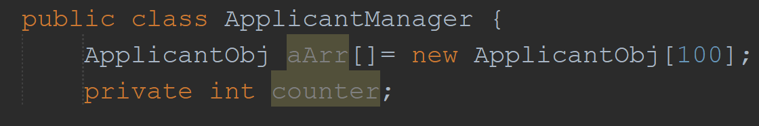
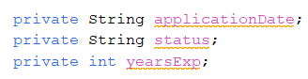
Data is loaded into the ApplicantManager class from tblApplicants through the connect class in the format of the ApplicantObj object class. aArr[]:ApplicantObj is the primary data structure which will represent ApplicantAdmin which is the secondary data structure. The fields in ApplicantAdmin match the variables in the ApplicantObj object class. ApplicantObj is a child class of Member and therefore it inherits the ID, firstName, surname, phoneNumber , age and Instrument fields.
Fields | aArr[0] | aArr[1]
aArr[i].memberID | 1 | 2
aArr[i].firstName | Yandisa | John
aArr[i].surname | Dambuza | Pork
aArr[i].phoneNumber | 0687273648 | 0993857289
aArr[i].age | 18 | 18
aArr[i].instrument | Vocals | Drums
aArr[i].applicationDate | 2025-07-01 | 2025-07-10
aArr[i].status | Pending | Pending
aArr[i].yearsExperience | 0 | 0

Events
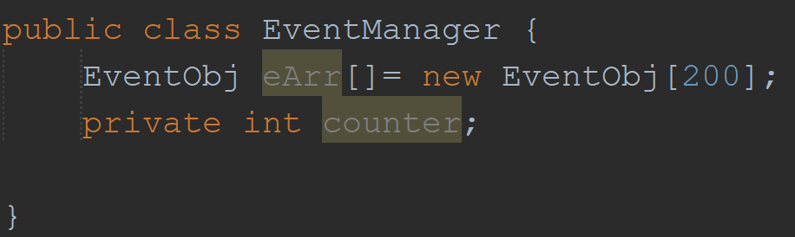
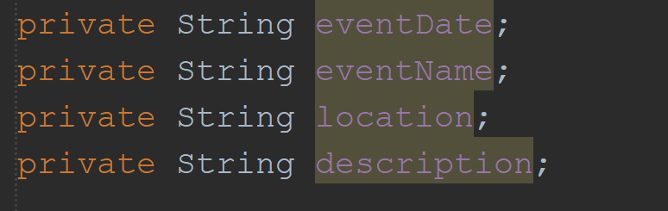
Data is loaded into the EventManager class from tblEvents through the connect class in the format of the EventObj object class. eArr []:EventObj is the primary data structure which will represent tblEvents which is the secondary data structure. The fields in tblEvents match the variables in the EventObj object class.
FIELDS | eArr[0]
eArr[i].eventID | 1
eArr[i].eventDate | 2025-08-14
eArr[i].eventName | Camp FloggNaw
eArr[i].location | US, Arizona
eArr[i].description | Duet

